1. Source Code

Latihan1.php -> Controller

Latihan2.php -> Controller

Model1.php -> Model

view-latihan2.php -> View

1. URL

<http://localhost/pustaka_booking_5C/index.php/Latihan1/penjumlahan/5/4>

<http://localhost/pustaka_booking_5C/index.php/Latihan2/penjumlahan/3/6>

1. Capture Outout Program

Latihan1

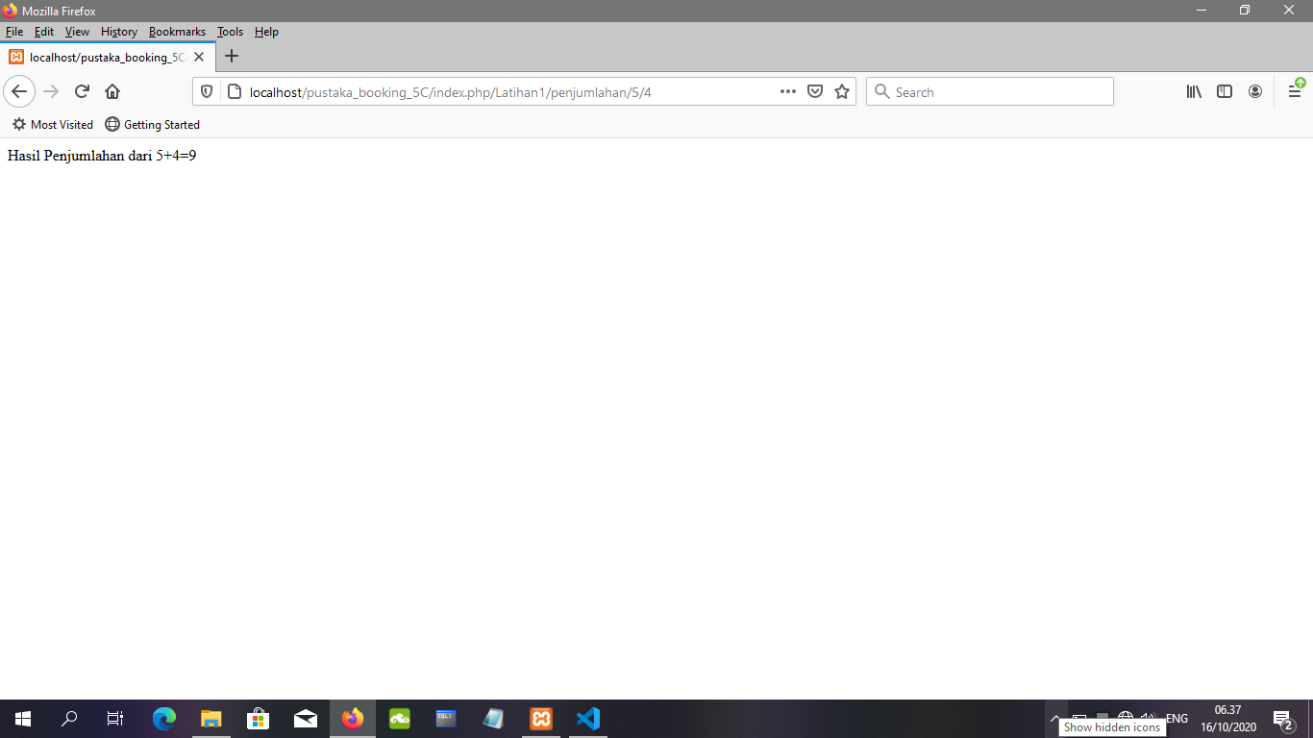

Latihan2

